Tile House Surgery - New Patient Registration Form
Please complete all pages in full using block capitals

1. Background Details

Contact Details
Name |  |  |  | Date of Birth
Address
Mobile Number |  |  | I consent to be contacted by SMS* |  |  | Yes / No
Home telephone |  |  | I consent for the surgery to leave messages on the home answerphone* |  |  | Yes / No
Email address
I consent to be contacted by email address* |  | Yes / No | Family Registered With Us |  |  | Yes / No
Next of Kin | Name:
 | DOB: |  |  | Tel:
 | Relationship:
* It is your responsibility to keep us updated with any changes to your contact details.

Other Details
Ethnicity | White (UK)  White (Irish)  White (Other):  ……………………  other: …………… |  | Black Caribbean  Black African  Black (Other):  ……………………. |  | Bangladeshi  Indian  Pakistani  Chinese
Have you ever been a member of the Armed Forces | Yes  No |  | If Yes, please indicate which Armed Force | Army Navy Marines RAF  Other ……………
Overseas Visitor | Yes | European Health Insurance Card Held (please bring details with you)

Communication Needs
Language | What is your main spoken language? ……………………………………………………..…….  Do you need an interpreter? Yes No
Communication | Do you have any communication needs? Yes No (If Yes please specify below)
 | Hearing aid  Lip reading  British Sign Language | Large print  Braille  Makaton Sign Language  Guide dog

Carer Details
Are you a carer? | Yes – Informal / Unpaid Carer |  | Yes – Occupational / Paid Carer
Do you have a carer? | Yes | Name*: | Tel: | Relationship:
* Only add carer’s details if they give their consent to have these details stored on your medical record

2. Medical History

Family History
Please record any significant family history of close relatives with medical problems and confirm which relative e.g. mother, father, brother, sister, grandparent

Asthma…………………………  COPD………………...………..  Epilepsy……………………….  Thyroid……………………….. | Heart Disease…………….……..  Stroke………..…….……………..  Blood Pressure…………………  Liver Disease ……….…….....
Diabetes………..…….………. Depression…………………… Kidney Disease ……..….....… Cancer…………………………….
…………………………………………..
Other:……………………………

Allergies
Please record any allergies or sensitivities below: | Symptoms:

Chronic Disease management
Please circle your preferred method of contact for Chronic disease management. |  |  | Letter / SMS
3. Your Lifestyle : Alcohol l
Please answer the following questions which are validated as screening tools for alcohol use:

AUDIT–C QUESTIONS | Scoring System |  |  |  |  |  |  | Your Score
 | 0 | 1 |  | 2 | 3 | 4
How often do you have a drink containing alcohol? | Never | Monthly or Less |  | 2-4 times per month | 2-3 times per week | 4+ times per week
How many units of alcohol do you drink on a typical day when you are drinking? | 1-2 | 3-4 |  | 5-6 | 7-9 | 10+
How often have you had 6 or more units if female, or 8 or more if male, on a single occasion in the last year? | Never | Less than monthly |  | Monthly | Weekly | Daily or almost daily
A score of less than 5 indicates lower risk drinking. |  |  |  |  |  | TOTAL

Scores of 5 or more requires the following 7 questions to be completed:
AUDIT QUESTIONS  (after completing 3 AUDIT-C questions above) | Scoring System |  |  |  |  | Your Score
 | 0 | 1 | 2 | 3 | 4
How often during the last year have you found that you were not able to stop drinking once you had started? | Never | Less than monthly | Monthly | Weekly | Daily or almost daily
How often during the last year have you failed to do what was normally expected from you because of your drinking? | Never | Less than monthly | Monthly | Weekly | Daily or almost daily
How often during the last year have you needed an alcoholic drink in the morning to get yourself going after a heavy drinking session? | Never | Less than monthly | Monthly | Weekly | Daily or almost daily
How often during the last year have you had a feeling of guilt or remorse after drinking? | Never | Less than monthly | Monthly | Weekly | Daily or almost daily
How often during the last year have you been unable to remember what happened the night before because you had been drinking? | Never | Less than monthly | Monthly | Weekly | Daily or almost daily
Have you or somebody else been injured as a result of your drinking? | No |  | Yes, but not in last year |  | Yes, during last year
Has a relative or friend, doctor or other health worker been concerned about your drinking or suggested that you cut down? | No |  | Yes, but not in last year |  | Yes, during last year
TOTAL

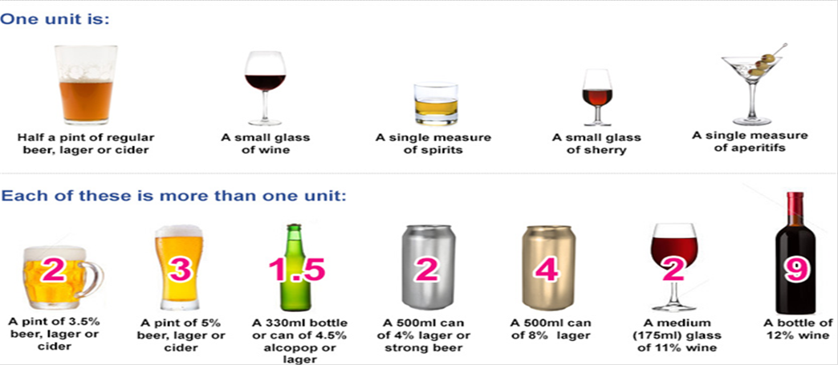

3. Your Lifestyle - Continued
Smoking
Do you smoke? | Never smoked | Ex-smoker |  | Yes
Do you use an e-Cigarette? | No | Ex-User |  | Yes
How many cigarettes did/do you smoke a day? | Less than one | 1-9 10-19 | 20-39 40+
Would you like help to quit smoking? | For further information, please see: www.nhs.uk/smokefree

Women Only
Do you use any contraception? | Yes No If needed, please book appointment.
Are you currently pregnant or think you may be? | Yes No Expected due date:

Students Only
Students are at risk of certain infections including mumps, meningitis and sexually transmitted infections, as well as mental health issues including stress, anxiety and depression.
Please see www.nhs.uk/Livewell/Studenthealth

Electronic Prescribing
Name of the pharmacy you would like your prescriptions to be sent to electronically | Pharmacy:
Signatures
I confirm that the information I have provided is true to the best of my knowledge.

Signature |  | Signed on behalf of patient
Print Name
Date
4. Sharing your Health Record

Please read information below before completing this form

Your Health Record
Do you consent to your GP Practice sharing your health record with other organisations who care for you?
Yes (recommended option)
No (not recommended, please discuss this with your GP before ticking this option)

Do you consent to your GP Practice viewing your health record from other organisations that care for you?
Yes (recommended option)
No

Sharing Your Health Record

Your health record contains all the clinical information about the care you receive. When you need medical assistance it is essential that clinicians can securely access your health record. This allows them to have the necessary information about your medical background to help them identify the best way to help you. This information may include your medical history, medications and allergies.

Health records about you can be held in various places, including your GP practice and any hospital where you have had treatment. Sharing your health record will ensure you receive the best possible care and treatment wherever you are and whenever you need it. Choosing not to share your health record could have an impact on the future care and treatment you receive. Below are some examples of how sharing your health record can benefit you:
- Sharing your contact details This will ensure you receive any medical appointments without delay
- Sharing your medical history This will ensure emergency services accurately assess you if needed
- Sharing your medication list This will ensure that you receive the most appropriate medication
- Sharing your allergies This will prevent you being given something to which you are allergic
- Sharing your test results This will prevent further unnecessary tests being required

Checklist
Please ensure the following are done and provided so that your registration can be completed successfully

Completed & Signed Above Form
Completed & Signed GMS1 Form
If you are on repeat medication please ensure you have at least 30 days of medication from your current surgery.
If you are on repeat medication please ensure you make an appointment with our Prescriber before you put in a new prescription request with us.

